

khaled alkisswani
mayas HamdaN

Pipelined risc-v processor
computer architecture 2
Abstract
This report outlines the design, implementation and evaluation of a five-stage pipelined RISC-V processor. The Processor utilizes the core principles of pipelining to dissect instructions into five stages | Instruction-Fetch | Instruction Decode | Execution | Memory-Access | Write-Back, to improve effectiveness and performance. The design uses traditional computer design components such as control units, ALU, memory operations and hazard detection mechanisms. This Implementation through test benches and benchmarks proves a significant performance boost over single cycle processors. Despite the aforementioned, this design technique still faces problems with branch prediction and hazard handeling.

Contents
Introduction 2
2 Processor Design 3
2.1 Instruction Fetch Stage 3
2.2 Instruction Decode stage 3
2.3 Execution stage 3
2.4 Memory stage 4
2.5 Write back 4
2.6 Hazard Detection Unit 4
2.7 Branch Predictor 4
2.8 Forwarding Unit 4
2.9 Load Hazard Unit 4
3 Design Analysis 5
4 Performance Comparison and Analysis 6
5 Testing 7
5.1 Unpipelined Testing 7
5.2 Pipelined Testing 7
6 Conclusion 7

Introduction
Since the Invention of the vacuum tube, human ingenuity has chased one major goal in their pursuit of technological excellence, efficiency, and when the core principals of Moor’s Law started to get challenged by the real world capabilities of electronics, engineers had to find another way to get the most out of their hardware. Complex architectures were developed to combat that among which the 5-staged Pipeline RISC-V processor represents a fundamentally paramount streamlined design method that excels in optimizing throughput. This report explores the detailed design process, simulation and testing of such implementation while outlining challenges and the design’s limitation.
The architecture of this processor is built on five distinct modules, each utilizing various components of the CPU to perform a specific stage of the instruction execution. Each instruction is divided into five sequential stages, which take advantage of the principles of pipelining. This was made possible using dedicated registers between each stage that acted as buffers, which facilitated smooth Input, and output of information between stages.
The Instruction Fetch (IF) stage is the first to be initiated for any instruction, during which the instructions are fetched from the program counter (PC). These instructions are then passed onto the following stage, The Instruction Decode (ID) stage, where they are decoded into control signals. Simultaneously, branch determination also occurs in this step but is not utilized until the next stage. Execution (EXE) stage is up next, where arithmetic and logic operations are performed, any addresses are also calculated if load and store operation are present.
Memory (MEM) stage is then initiated where memory-related operations such as loads and stores occur. Last but not least, the Write-back (WB) stage, where the results of the operations are written back onto the registers.
The registers placed between each stage serve as laches, by synchronizing and distinguishing the flow of instructions. These registers help nullify data hazards and maintain data integrity between the different stages, ensuring proper sequencing and data corruption.

2 Processor Design

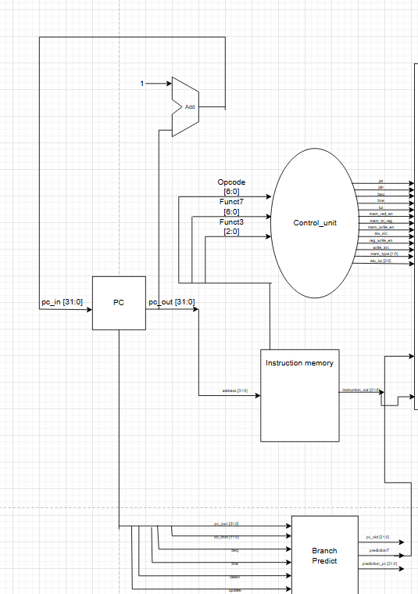
2.1 Instruction Fetch Stage
The instruction is first fetched from the instruction memory. After that, it is decoded in the control unit and if need be, provided to the branch predictor to determine the next PC address.

A two-bit predictor predicts the correct PC address, with at most, 1 cycle wasted.
It then updates data signals to perform any load or store instructions, then uses write-back to avoid data mismatch.
This stage also takes care of identifying what type of instruction is being fetched which helps in the decode

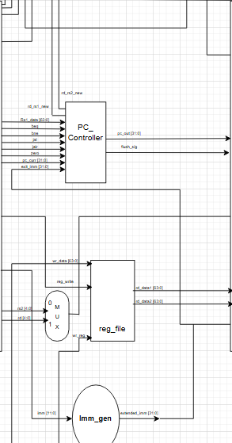

2.2 Instruction Decode stage
This stage takes advantage of how we assigned the function types in the IF stage, it handles the opcode and funct3,7 in order to determine what the instruction actually is, it also determines what the immediate value is.
The ID stage also takes care of branch functions by utilizing the pc controller and then offloads the necessary data onto the ID_EXE register

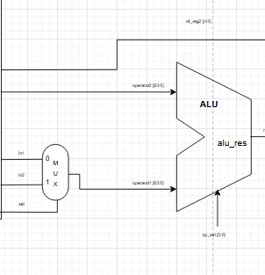
2.3 Execution stage
Takes the “raw goods” per say procured in the previous two stages and gives us a finished product. This stage contains the load-use hazard detection and handles forwarding.

2.4 Memory stage
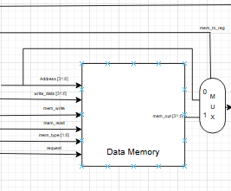
The MEM stage is only utilized when memory access is needed, mainly read and write instructions. The memory stage organizes memory tasks, and since there is no caching involved, there is no variation in the CPI because we don’t have to worry about misses.

2.5 Write back
In this stage, the instruction is concluded, and although many instructions do not utilize it, its still helps write data back onto the registers

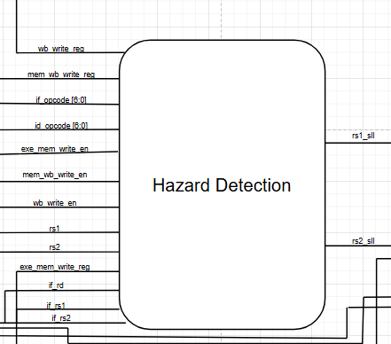
2.6 Hazard Detection Unit
This unit is responsible for detecting control or ALU hazards. This is done through various conditions that act as filters to nullify the chance of a hazard. These conditions are built with regards to the instruction type and order in the pipeline.

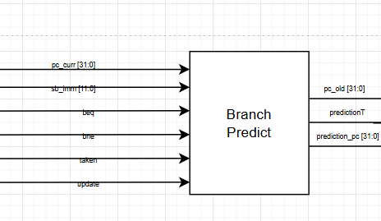
2.7 Branch Predictor
A simple 2-bit branch predictor that is used to help predict the outcome of a branch instruction in order to decrease the number of wasted cycles.

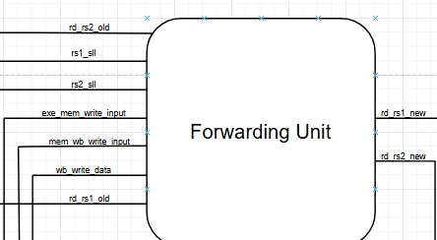

2.8 Forwarding Unit
Our Forwarding unit is designed to handle data hazards in a pipelined processor by selecting the most up to date values for source operands before they are used in the EXE stage. The unit checks the forwarding control signals to determine where the operands should come from.

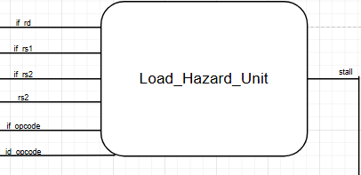
2.9 Load Hazard Unit
The load hazard unit’s main purpose is to stall the pipeline when a load hazard occurs which prevents incorrect executions caused by the lack of data integrity

3 Design Analysis
Our design was built on the idea of utilizing tried and tested methods to achieve maximum efficiency when it comes to handling instructions, branch prediction and forwarding. The implementation of a separate PC controller allowed us to----. The definition of each stage early on helped us handle pipelining easily as we mapped out the stages in phase 1.
Building the pipeline first relied on understanding what should be ready by the end of each stage, and what each stage expects as inputs in order for it to function properly. The registers built between each stage help standardize instruction handling and in turn facilitate pipelining.
The branch predictor addressed the control hazards while also decreasing the cycles need for any branch instruction. It is a 2- bit branch predictor that looks at the likelihood of each outcome. It outputs the predicted_pc to the ID stage to be handled and forwarded to the next stage.
To avoid data hazards, we implemented forwarding at the EXE stage. The forwarding unit detected any data dependencies between instructions and routed the data directly from the EXE to the IF of the next instruction. This also contributed to decreasing execution time and subsequently improving performance.

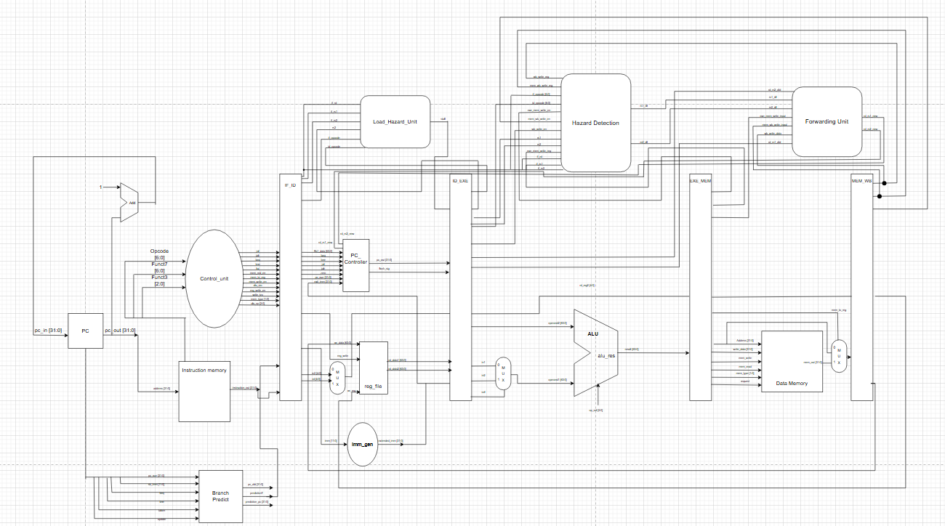

4 Performance Comparison and Analysis

We know from our studies the following equation:
$$Speedup=\frac{{Performance}_{Pipelined}}{{Performance}_{single-cycle}}=\frac{{CPI}_{single-cycle} × {Cycle Time}_{single-cycle}}{{CPI}_{Pipelined} × {Cycle Time}_{Pipelined}}$$

And since the CPI is unaffected by whether the CPU is pipelined or single-cycled and is ideally 1, we can remove it from the equation. This leaves the speedup solely reliant on the cycle time. Let us assume we are in a theoretical Scenario with no stalls, then the speedup will be equal to:
$$Speedup=\frac{{Cycle Time}_{single cycle}}{{Cycle Time}_{pipelined}}=\frac{500}{100}=5$$

However, this is nearly impossible to achieve, and a more accurate representation of the performance benefit would be:
$$Speedup=\frac{500}{100×{CPI}_{pipelined}}$$
And since we are not in ideal scenarios, the CPI > 1, assuming our CPI has risen to 1.45, our new Times will equal
$$T_{pipelined}=(k+n-1)×T_{pipe}$$
Where;
$$k=number of pipelined stages$$
$$n=Numbers of Instructions to Execute$$
$$T_{pipe}=Time of slowest stage in pipeline$$
$$T_{pipelined=Time of Pipelined CPU}$$

This shows us that although the speedup will never reach 5, it will still be greater than even the ideal single cycle processor meaning that the pipelined processor will always perform better than the it.

5 Testing

5.1 Unpipelined Testing
The following are the results of our testbench before the implementation of pipelining:
- Instruction Fetch:
- Instruction Decode:
- EXE:
- MEM: (error here because online compiler was used without hex file)
- WB:

5.2 Pipelined Testing

6 Conclusion
In conclusion, the implementation of a 5-stage pipelined RISC-V processor is a remarkable testament to the ingenuity processors have undergone over the last few decades. The dissection of instructions into separate modules tasked to perform a certain part of the instruction has proven to significantly increase performance in comparison with single-cycled processors, and would ideally result in a x5 improvement in CPU throughput. However, as long as data dependencies and branch mispredictions exist, the full potential of pipelined execution may never be fulfilled, leaving us with tradeoffs that we must acknowledge.
Through rigorous testing, our model proved to be reliable in arithmetic calculations, memory access and branching tasks. Challenges encountered throughout our testing process where handled by multiple iterations of our hazard detection and control strategies to ensure the correct outcome. And while pipelining proved to be a major performance booster, our design still lacks other architectural design methodologies such as Caching which can be vital to modernizing our design to keep up with real-world demand.

